What is a city?
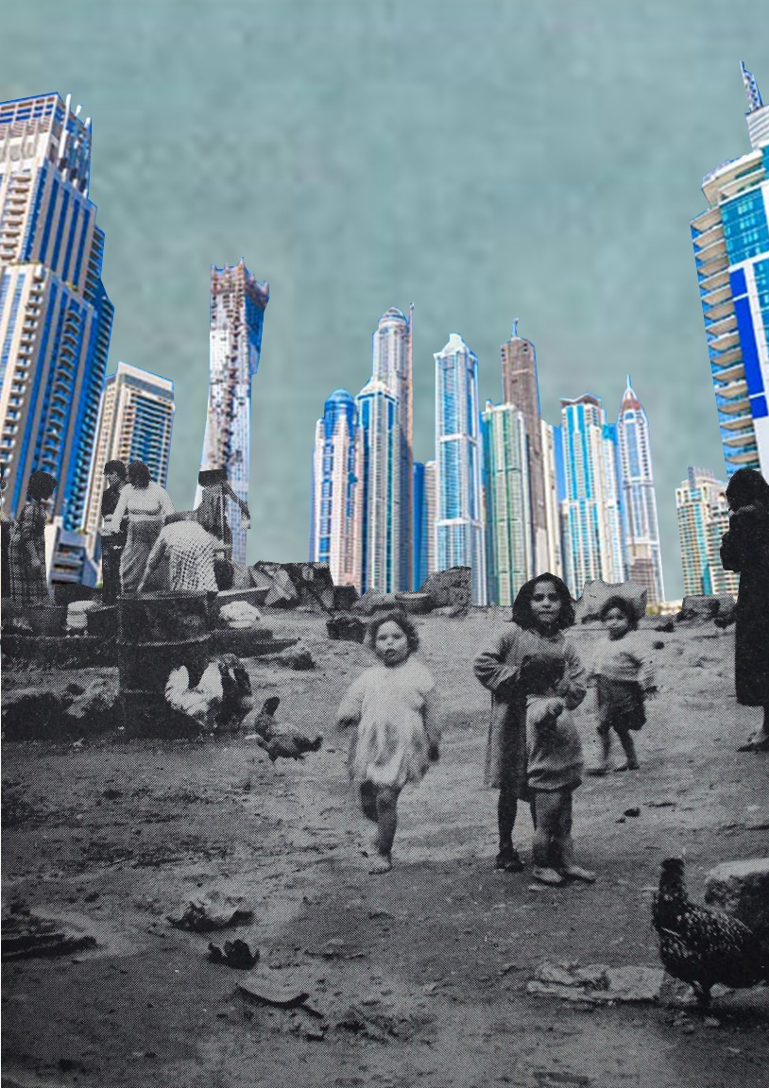
The city was born as a place of opportunity: the modern city is the consequence of the industrial revolution, which leads men to organize themselves in suitable locations. Then, due to population growth and growing complexity of technology and economics, the city becomes a space of inequality and social problems. Nowadays, the inequality shows itself in the difference between center and periphery. Lack of services, inadequate structures for education, crumbling infrastructures, urban and enviromental degradation are the manifestation of inequality. And these are also elements that lead to social segregation. For example, in Rome, the graduates are four times more than in the peripheries. I use the word “peripheries” not only in a spacial way, but mostly to describe a phenomenon of urban decay. For example, Cortile Cascino, synonimous of decay and poverty in the city of Palermo, was a stone’s throw from the palaces of politics and religion, in the center of the city. Talking about Dubai, the question is: what happens to cities when real estate investments abound, regulation is weak, and urban trasformation becomes hyper-accelerated? Dubai has the highest skyscraper in the world, but has a huge gap between rich and poor; its economy is hyperaccelerated, but there are no places for waste disposal. In this, Radical urbanism could be a lesson for the future architecure: “utopian dreams tempered by an unflinching engagement with social reality” (cit. https://archpaper.com/2017/04/radical-urbanism-evolving-urbannext/), usually through a positivist attitude. We, as future architect, can learn by them and their idea of a new humanism, based on the respect for the individual and the reality that sorrounds him.

Giorgia Calandra

